Exercise 13
- Which Command displays the MSQL version?
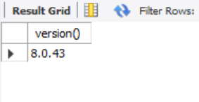

- Use the SELECT command to evaluate 4X4X4 and name the column Cube of 4.
select ((4*4*4)) as "Cube of 4";
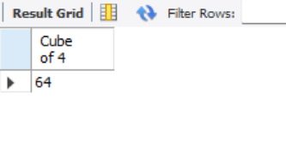
- Display your name with SELECT.
Select “PATRICK” as Name;

